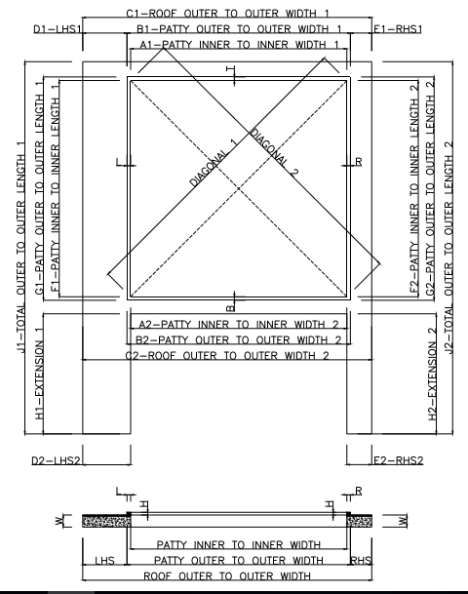
700

A1 | 6430 | A2 | 6430
B1 | 6630 | B2 | 6630
C1 | 7130 | C2 | 7130
D1 | 250 | D2 | 250
E1 | 250 | E2 | 250
F1 | 5350 | F2 | 5350
G1 | 5550 | G2 | 5550
H1 | 700 | H2 | 700
J1 | 6950 | J2 | 6950
DIAGONAL 1 | 8363 | DIAGONAL 2 | 8363
W | 100 | H | 100
L | 100 | R | 100
T | 100 | B | 100

CLIENT NAME - ………………………………………………
SITE LOCATION - ………………………………………………

Point to be observed –
- Top beam surface should be smooth (granite/marble) for proper movement of roof.
- The concrete patty and the beam should be a single structure so to avoid any joints. If any joints then it should be properly sealed to make them leak proof.
- There should be a slope of 50 mm along the length to avoid water stagnancy.
- Check the electrical point connection on site and mark the location as per the site.
- Consider all the dimension in MM.

